FUNCTIONS:

This is function:
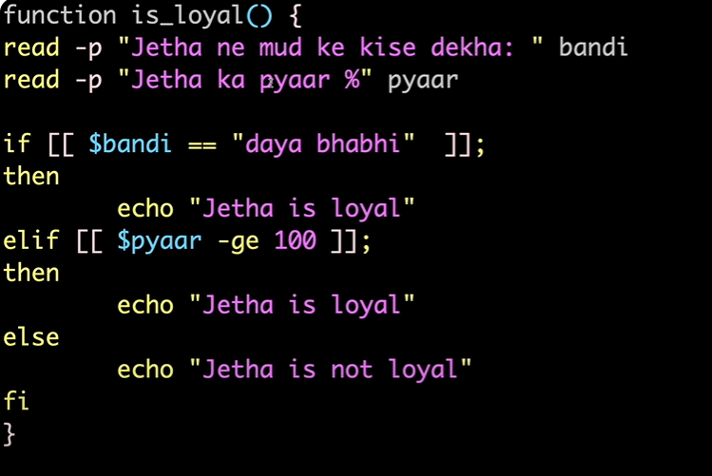

Function is called here:
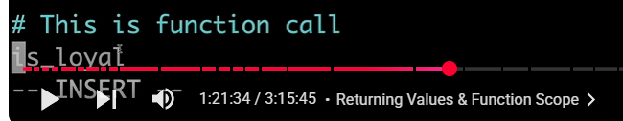

Function would start running as, we have called the function:
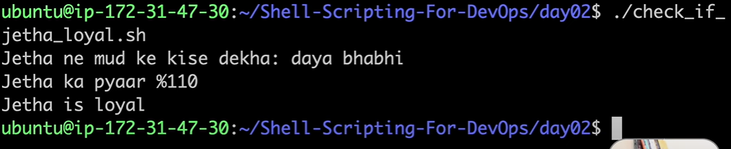

Now, if we try to pass the arguments, and pass from the command line while running the command:
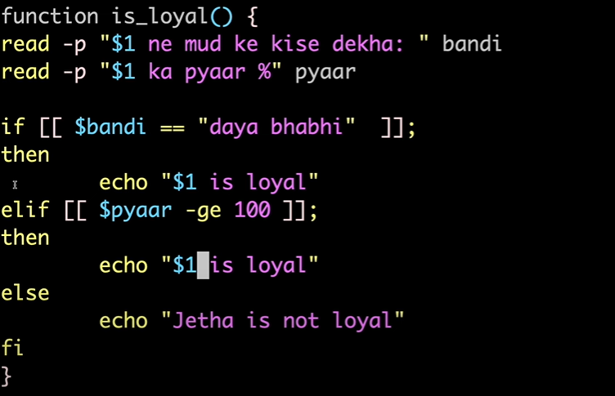

Pass the same from the function name as:
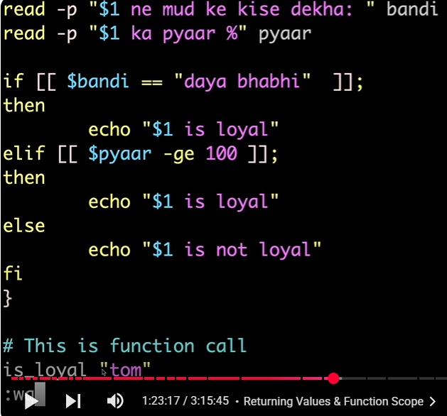

When we run the shell script following would be the output:
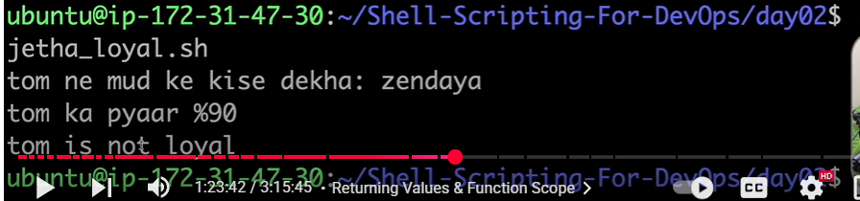

INTERMEDIATE SCRIPTING TECHIQUES:
In Java, we use the try catch to check the error, but in the shell scripting, we can use the “if” and “then” for the same.
Creating the day03 folder and making the script:
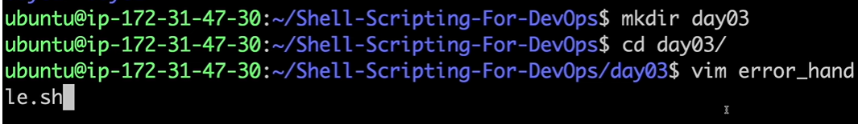

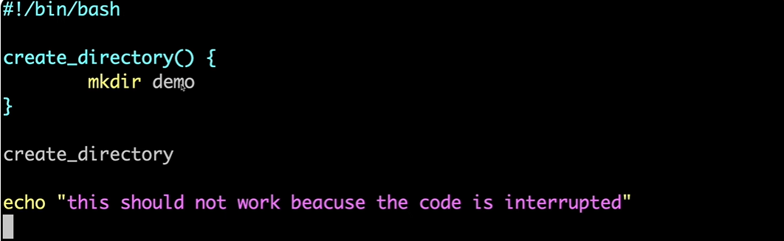
In the first go, demo folder would be created:
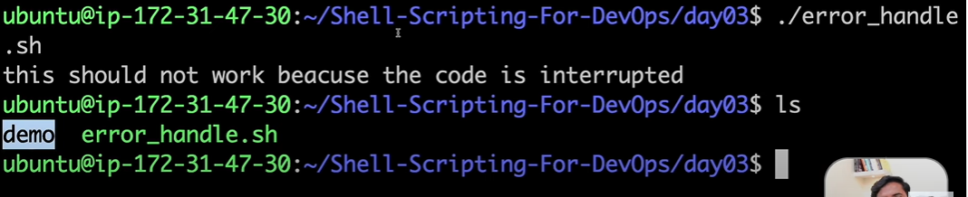

If we run the shell script again, following would be the output:
